**Smart Timesheet Management System**

***Demo Project Report***

***Cognizant Technology Solutions***

***Submitted by***

***Team F***

**COHORT CODE: INTCDB21DW029**

**July 2021**

**ACKNOWLEDGEMENT**

We express our humble gratitude to **Cognizant Technology Solutions India Private Limited** for the wonderful internship opportunity and the facilities extended for the project work.

We extend our sincere thanks to our coach **Sunandha Kakara** and all our trainers for their invaluable support.

**Team F,**

**INTCDB21DW029**

**ROLES AND RESPONSIBILITIES**

|  |  |  |
| --- | --- | --- |
| **NAME** | **EMPLOYEE ID** | **CONTRIBUTION** |
| SANTHOSH KASIRAJAN | 914683 | Frontend (HTML, CSS), Documentation |
| ABINAYA K | 914748 | Frontend (HTML, CSS), Documentation |
| MEDHA M | 914700 | Frontend (HTML, CSS), Documentation |
| KANTHIMATHI S | 914571 | Backend (MySQL, Python), Documentation |
| PREM RAJ S (Team Lead) | 916692 | Backend (Python, Flask), Documentation |
| PREETHI S | 918555 | Frontend (HTML, CSS), Documentation |

# **ABSTRACT**

Web-based time-sheet system assists in assigning projects to specific employees, measures performance and productivity, and provides an automated method of calculating salary for employees based on their total work time. This system is a web application that provides an automated method of tracking work time for employees by enabling the manager to track their work time.

Additionally, the technology allows employees and managers to communicate directly. One of the system's main advantages is that any employee may enter into his account and complete the projects that have been given to him. According to their responsibilities, an employee, a manager, and a secretary each have distinct powers. In addition, the system was created utilising HTML, CSS, and PHP, with a SQL database. As seen by the results of the questionnaire, the web-based timesheet system was successfully tested and received high levels of satisfaction.

**TABLE OF CONTENTS**

|  |  |  |
| --- | --- | --- |
| **S.NO** | **TITLE** | **PAGE NO** |
| 1 | INTRODUCTION | 8 |
| 2 | PROJECT OBJECTIVE | 9 |
| 3 | PROBLEM STATEMENT | 9 |
| 4 | PROPOSED SYSTEM | 10 |
| 5 | LANGUAGES USED | 13 |
| 6 | DATABASE | 16 |
| 7 | SOFTWARE | 17 |
| 8 | RESULTS | 18 |
|  | 8.1 MAIN SCREEN | 18 |
|  | 8.2 EMPLOYEE LOGIN SCREEN | 20 |
|  | 8.3 EMPLOYEE HISTORY SCREEN | 21 |
|  | 8.4 EMPLOYEE TIMESHEET ENTRY SCREEN | 24 |
|  | 8.5 ADMIN LOGIN SCREEN | 28 |
|  | 8.6 ADMIN SELECT SCREEN | 29 |
|  | 8.7 ADMIN PENDING SCREEN | 30 |
|  | 8.8 ADMIN APPROVED SCREEN | 34 |
|  | 8.9 ADMIN ALL SCREEN | 37 |
|  | 8.10 PROJECT DATABASE PYTHON | 39 |
| 9 | CONCLUSION | 41 |

**LIST OF FIGURES**

|  |  |  |  |  |
| --- | --- | --- | --- | --- |
| **S.NO** | **FIGURE NAME** | **PAGE NO** | | |
| **1** | WEBSITE ARCHITECTURE | | 10 |
| **2** | DATABASE SCHEMA | | 11 |
| **3** | VISUAL STUDIO CODE IDE | | 17 |
| **4** | MAIN SCREEN | | 18 |
| **5** | EMPLOYEE LOGIN SCREEN | | 20 |
| **6** | EMPLOYEE HISTORY SCREEN | | 22 |
| **7** | EMPLOYEE TIMESHEET ENTRY SCREEN | | 25 |
| **8** | ADMIN LOGIN SCREEN | | 28 |
| **9** | ADMIN SELECT SCREEN | | 30 |
| **10** | ADMIN PENDING SCREEN | | 31 |
| **11** | ADMIN APPROVED SCREEN | | 35 |
| **12** | ADMIN ALL SCREEN | | 37 |

**LIST OF ABBREVIATIONS**

|  |  |
| --- | --- |
| **HTML** | Hypertext Markup Language |
| **CSS** | Cascading Style Sheets |
| **SQL** | Structured Query Language |
| **SSMS** | SQL Server Management Studio |
| **IDE** | Integrated Development Environment |
| **GUI** | Graphical User Interface |
| **DMA** | Data Migration Assistant |
| **API** | Application Programming Interface |

1. **INTRODUCTION**

Every firm must have a time-sheet system in place. This is a formal evidence and document that specifies the amount of money owed to the employee based on the number of hours worked. Most timesheets are now written on paper. Paper-based timesheets may be a stumbling block for businesses seeking to increase efficiency. Paper timesheets take up a lot of office space, which costs money and takes time to process and submit. In addition, the paper-based time-sheet might be untrustworthy at times.

Paper timesheets are particularly prone to errors since distinguishing time data from employees who handwrite their time might be difficult. Data transcription mistakes happen as a result of this. Another problem with paper-based timesheets is that it is possible to record someone else's time and no one will notice. Managers can use this approach to establish ghost payroll, in which they make up hours for workers who no longer work there.

All of the issues result in a waste of time and resources. To tackle the concerns stated above, changes are required; one option for addressing the issues is to develop a web-based timesheet. A web-based time-sheet is a web application that can be a good alternative for a paper-based time-sheet because it is digital and takes up no physical space. Furthermore, timesheets printed on paper take up a lot of storage space.

A web-based timesheet, on the other hand, saves time and is quite trustworthy. Nobody may claim to have worked more than a certain number of hours. Furthermore, the total time work computation is correct when using a web-based timesheet. Managers cannot construct a ghost payroll using web-based timesheets, and web-based timesheets are more accurate than paper-based timesheets. All of the aforementioned enhancements ensure increased productivity, time savings, and cost savings. The goal of this project is to develop a web-based timesheet to replace the paper timesheet. To save time, money, and personnel, the web application will be a basic website. Efficiency, productivity, precision, and agility are all possible with this technology.

1. **PROJECT OBJECTIVE**

The proposed project's ultimate goal is to create a smart timesheet and client management system that will assist the client in managing and viewing data in a more efficient manner. The project's overarching goals may be broken down into four categories:

* To update the client timesheet to reflect changes made to the employee timesheet.
* To create reasoning that reflects the most recent updates.
* To use SQL Server, HTML, and other tools and technologies to accomplish the logic.
* To create a client timesheet that is more user-friendly.

1. **PROBLEM STATEMENT**

Clients used to complain that the employee might modify the input data even after submitting the timesheet, causing a lot of confusion. The client couldn't view the prior data since it had been overwritten by the newly entered data. The issue is that there was no information available about the most recent time and date on which the employee updated the timesheet.

1. **PROPOSED SYSTEM**

**4.1 BLOCK DIAGRAM**

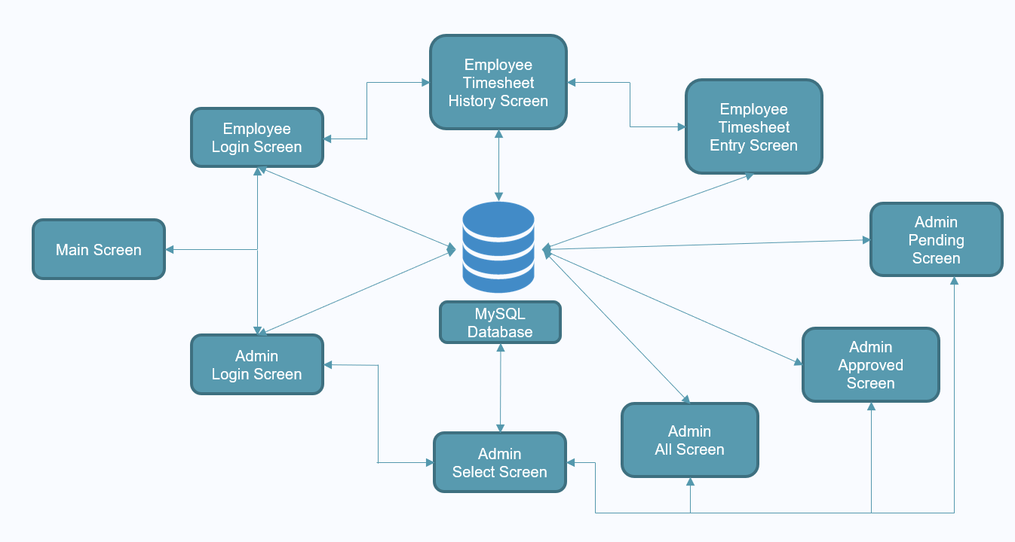

*Fig: 4.1 Website Architecture*

There are a total of 9 screens, the Main Screen where one can go to Admin Login and Employee Login where they can login respectively. In the Employee Timesheet History screen, one can view the previous submissions and the current weeks submission and their status and entries. In the Employee timesheet Entry screen, the employee can enter the working hours and submit. In the Admin Select Screen the admin can choose either Pending Screen, Approved Screen or All screen. Here in pending screen the admin can view all the pending timesheet submissions, the admin can approve or reject a timesheet submission. In the approved screen, the admin can view all the approved timesheet entries, In the all screen the admin can view all the submissions made by all the employees assigned to the admin. There is a search bar in each and every screen in admin side for searching.

**4.2 DATABASE SCHEMA**

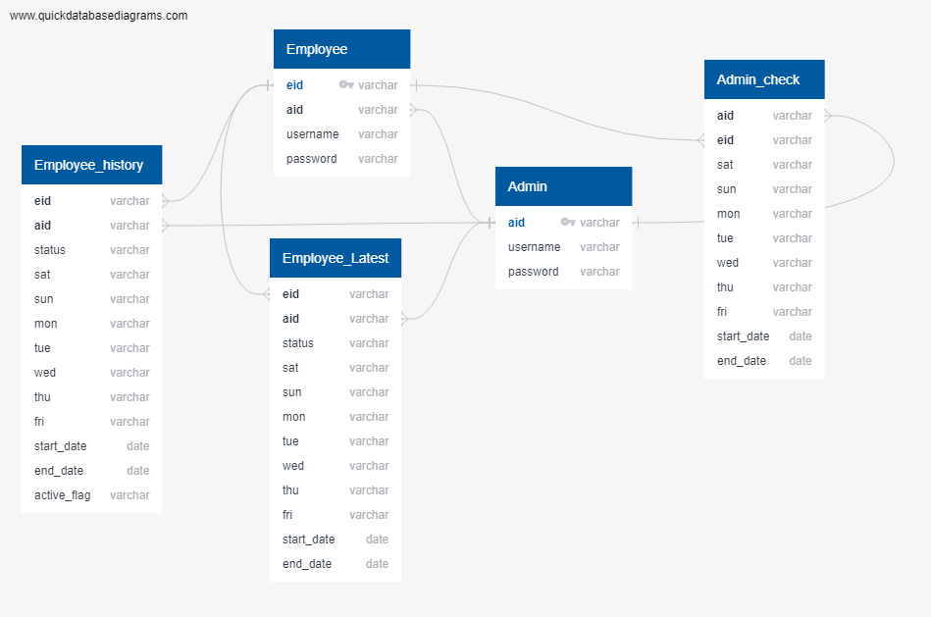

*Fig 4.2 Database Schema*

The Timesheet database consists of five tables. Each table has its own attributes and primary key which may be linked to the other table for reference. A primary key is a unique identifier of its own table. Some table has an attribute which is linked to the other table’s primary key is called foreign key. The description of each table is given as follows:

Admin:

The admin table consists of aid, username and password which describes the login credentials of each admin. The column aid is considered as the primary key of the admin table.

Employee:

This table consists of the login credentials for each employee such as eid, username and password. The column eid is considered as the primary key for this table. This table also includes a foreign key aid which is uniquely referred to the admin table’s primary key.

Employee_history:

This table consists of working hours for every day from Sunday to Monday, status which shows whether their timesheet is approved or not, starting day and ending day of the week, active flag along with eid and aid (foreign keys),

Employee_latest:

This table is same as employee_history table except the thing that this tables does not have active flag column.

Admin_check:

This tables are also same as employee_history except the fact that this table does not have both status and active flag.

**5. LANGUAGES USED**

**5.1 HYPERTEXT MARKUP LANGUAGE (HTML):**

**HTML** (Hypertext Markup Language) is the most basic building block of the Web. It defines the meaning and structure of web content. Other technologies besides HTML are generally used to describe a web page's appearance/presentation ([CSS](https://developer.mozilla.org/en-US/docs/Web/CSS)) or functionality/behaviour ([JavaScript](https://developer.mozilla.org/en-US/docs/Web/JavaScript)).Web browsers receive HTML documents from a web server or from local storage and render the documents into multimedia web pages. HTML describes the structure of a web page semantically and originally included cues for the appearance of the document.

The major points of HTML are given below:

* HTML stands for Hypertext Markup Language.
* HTML is used to create web pages and web applications.
* HTML is widely used language on the web.
* We can create a static website by HTML only.
* Technically, HTML is a Markup language rather than a programming language.

Applications of HTML

* **Web pages development** - HTML is used to create pages which are rendered over the web. Almost every page of web is having html tags in it to render its details in browser.
* **Internet Navigation** - HTML provides tags which are used to navigate from one page to another and is heavily used in internet navigation.
* **Responsive UI** - HTML pages now-a-days works well on all platform, mobile, tabs, desktop or laptops owing to responsive design strategy.
* **Offline support HTML** pages once loaded can be made available offline on the machine without any need of internet.
* **Game development**- HTML5 has native support for rich experience and is now useful in gaming development arena as well.

**5.2 CASCADING STYLE SHEETS (CSS)**

Cascading Style Sheets (CSS) is a [style sheet language](https://en.wikipedia.org/wiki/Style_sheet_language) used for describing the [presentation](https://en.wikipedia.org/wiki/Presentation_semantics) of a document written in a [markup language](https://en.wikipedia.org/wiki/Markup_language) such as [HTML](https://en.wikipedia.org/wiki/HTML). CSS is a cornerstone technology of the [World Wide Web](https://en.wikipedia.org/wiki/World_Wide_Web), alongside HTML and [JavaScript](https://en.wikipedia.org/wiki/JavaScript).

CSS is designed to enable the separation of presentation and content, including [layout](https://en.wikipedia.org/wiki/Page_layout), colours, and [fonts](https://en.wikipedia.org/wiki/Typeface). This separation can improve content [accessibility](https://en.wikipedia.org/wiki/Accessibility), provide more flexibility and control in the specification of presentation characteristics, enable multiple [web pages](https://en.wikipedia.org/wiki/Web_page) to share formatting by specifying the relevant CSS in a separate .CSS file which reduces complexity and repetition in the structural content as well as enabling the .CSS file to be [cached](https://en.wikipedia.org/wiki/Cache_(computing)) to improve the page load speed between the pages that share the file and its formatting.

Applications of CSS

* CSS saves time
* Pages load faster
* Easy maintenance
* Superior styles to HTML
* Multiple Device Compatibility
* Global web standards

**5.3 PYTHON**

Python is a high-level, general-purpose and a very popular programming language. Python programming language is being used in web development, Machine Learning applications, along with all cutting-edge technology in Software Industry. Python Programming Language is very well suited for Beginners, also for experienced programmers with other programming languages like C++ and Java.

Applications of Python:

* Web and Internet development
* Scientific and numeric computing
* Education purposes
* Software development
* ERP and e-commerce system development

**5.3.1 Libraries used:**

**5.3.1.1 Flask**

Flask is a popular Python web framework, meaning it is a third-party Python library used for developing web applications. This web application can be some web pages, a blog, a wiki or go as big as a web-based calendar application or a commercial website. Flask is part of the categories of the micro-framework. Micro-framework is normally framework with little to no dependencies to external libraries. This has pros and cons. Pros would be that the framework is light, there are little dependency to update and watch for security bugs, cons is that some time you will have to do more work by yourself or increase yourself the list of dependencies by adding plugins.

**5.3.1.2 Datetime**

The datetime module supplies classes for manipulating dates and times. Datetime module comes built into Python, so there is no need to install it externally. Datetime module supplies classes to work with date and time. These classes provide a number of functions to deal with dates, times and time intervals. Date and datetime are an object in Python, so when you manipulate them, you are actually manipulating objects and not string or timestamps.

**5.3.1.3 Flask-MySQLDB**

This flask-MySQLDB library is used to make a connection to the MySQL database, with the help of the entered credentials. With the help of this super light and fast library, performing queries to the database is very easy with python

**6. DATABASE**

**6.1 What is a Database?**

A database is a logically ordered collection of structured data kept in a computer system. A database management system (DBMS) is generally in charge of a database (DBMS). A database system, which includes the data, the DBMS, and the applications that go with it, is referred to as a database system, or simply database.

SQL (Structured Query Language) is a programming language that allows you to access and manage databases.

SQL can run queries against a database, obtain data from a database, insert entries in a database, update records in a database, remove records from a database, and build new databases and tables.

SQL may generate stored procedures in a database, views in a database, and set permissions on tables, procedures, and views in a database.

**6.2 MySQL**

MySQL is a relational database management system based on the Structured Query Language, which is the popular language for accessing and managing the records in the database. MySQL is open-source and free software under the GNU license. It is supported by Oracle Company.

It is fast, scalable, and easy to use database management system in comparison with Microsoft SQL Server and Oracle Database. It is commonly used in conjunction with PHP scripts for creating powerful and dynamic server-side or web-based enterprise applications.

**7. SOFTWARE**

**7.1 VISUAL STUDIO CODE**

* Visual Studio Code is a lightweight but powerful source code editor from Microsoft that runs on your desktop and is available for Windows, macOS, and Linux.
* It includes built-in support for JavaScript, TypeScript, and Node.js, as well as a rich ecosystem of extensions for other languages and runtimes (such as C++, C#, Java, Python, PHP, etc.)
* The same editor component (dubbed "Monaco") that is used in Azure DevOps is utilised in Visual Studio Code (formerly called Visual Studio Online and Visual Studio Team Services).
* Instead of a project management system, it enables users to access one or more folders, which may subsequently be stored in workspaces for future use. As a result, it may function as a language-independent code editor for any language.
* Visual Studio Code comes with source control built-in. We can access version control settings and observe changes to the current project using a dedicated tab in the menu bar.
* To utilise the functionality, we must connect Visual Studio Code to a version control system that supports it (Git, Apache Subversion, Perforce, etc.)
* We can use Visual Studio Code to build repositories as well as perform push and pull requests.

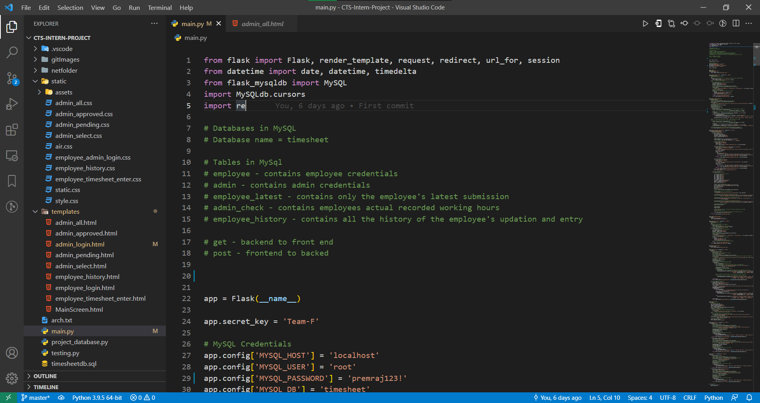

Fig: 7.1 Visual Studio Code IDE

**8. RESULTS**

Front-end web development is that the observe of changing knowledge to a graphical interface, through the utilization of hypertext mark-up language, CSS, and JavaScript, so users will read and act there with knowledge.

In this project, websites like home page, employee login, admin login has been created. In the home page, it’ll raise what page would the user prefer to login to, either employee or admin. Clicking on either of the choices, the home page would take to its explicit login page.

**8.1 MAIN SCREEN**

The home page has been created using html and CSS. The body section consists of employee login and admin login, wherever it redirects to the individual login pages.

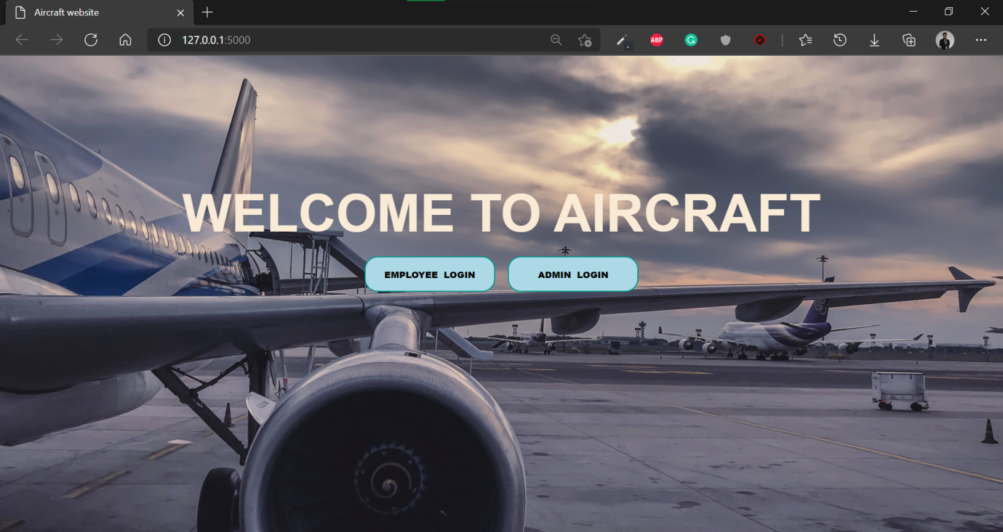

*Fig: 8.1 Main Screen*

**FRONT ENDCODE:**

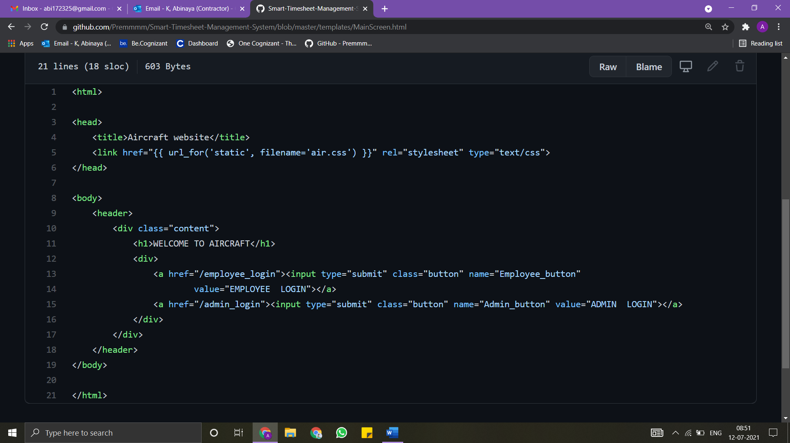

**BACKEND CODE:**

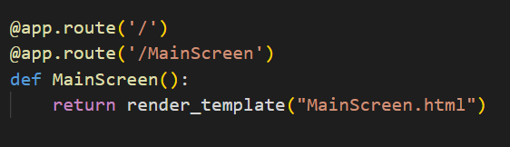

**8.2 EMPLOYEE LOGIN SCREEN**

On clicking on the employee login, the user is taken to the employee login page whereby the employee ought to enter their credentials to enter their several timesheet page. The user must fill the employee id, employee name and password in order to login the website.

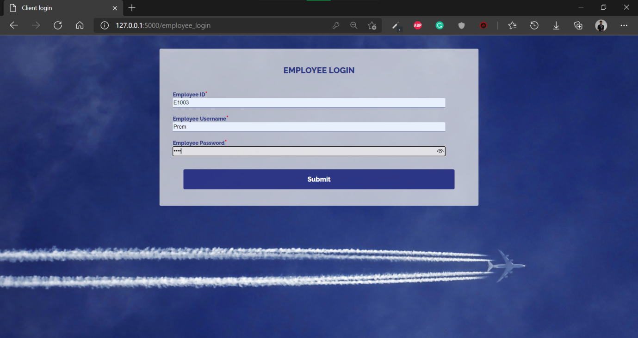

*Fig: 8.2 Employee Login Screen*

**FRONT END CODE:**

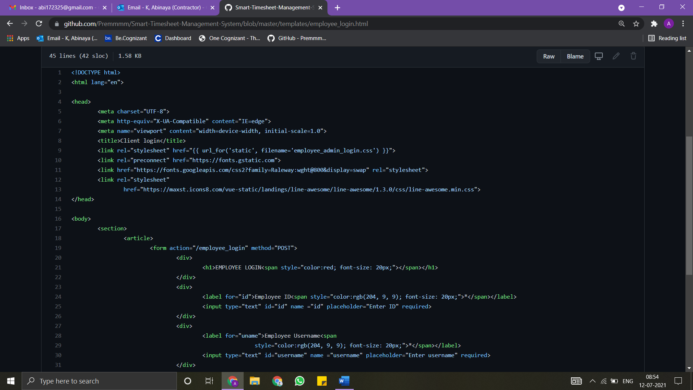

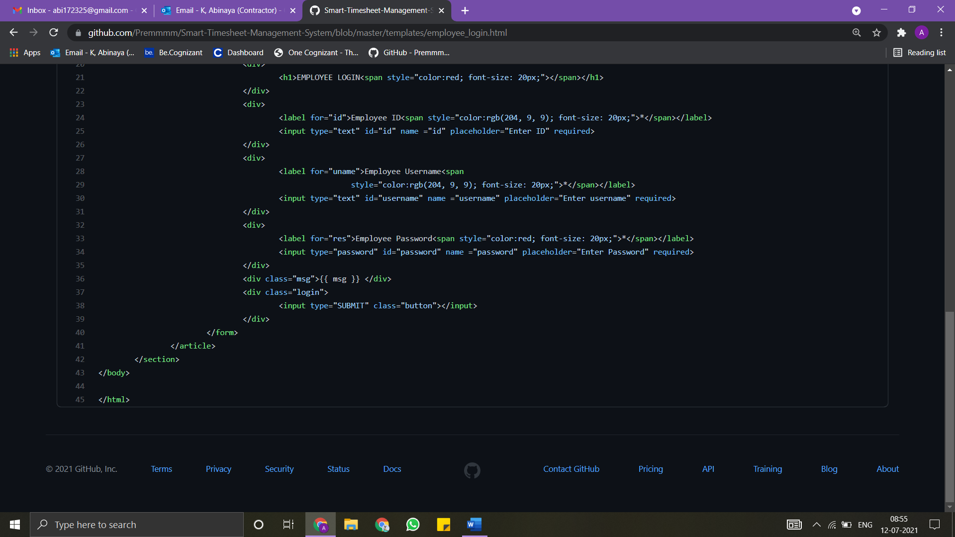

**BACKEND CODE:**

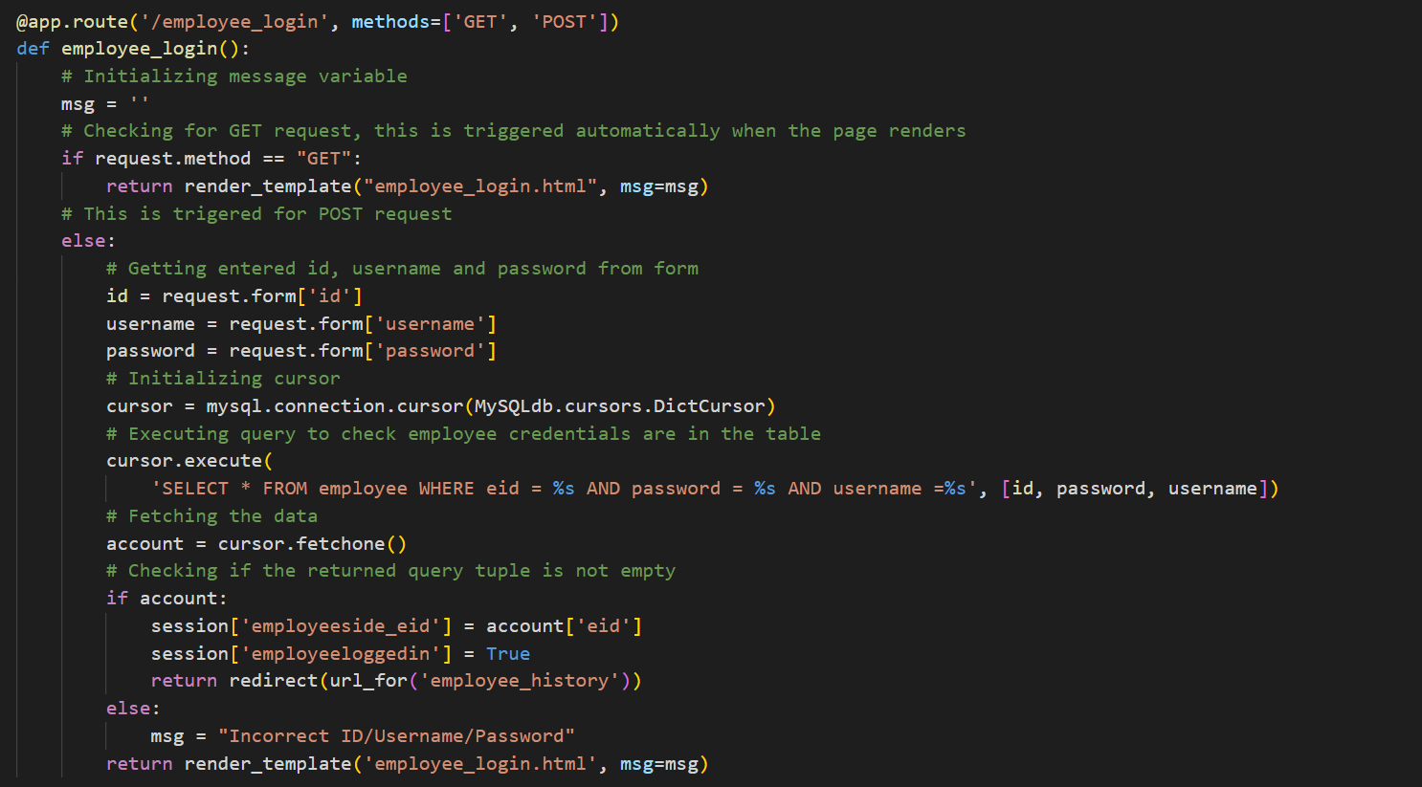

**8.3 EMPLOYEE HISTORY SCREEN**

On employee history page, the past submissions from the employee_history table which has an active flag Y will be queried and displayed, with the status. The current week’s submission will also be auto generated with start_date and end_date and be displayed for the user to select.

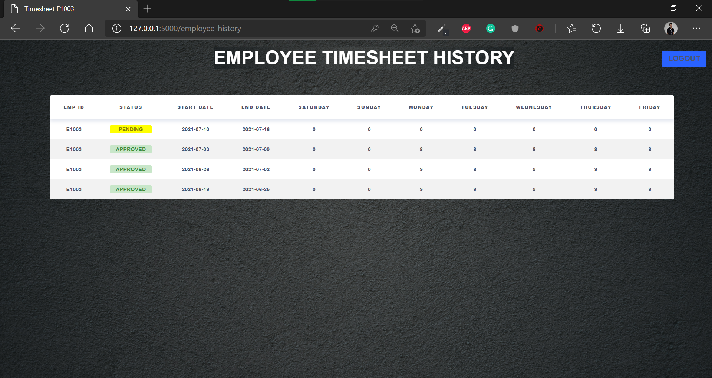

*Fig: 8.3 Employee timesheet history screen*

FRONTEND CODE:

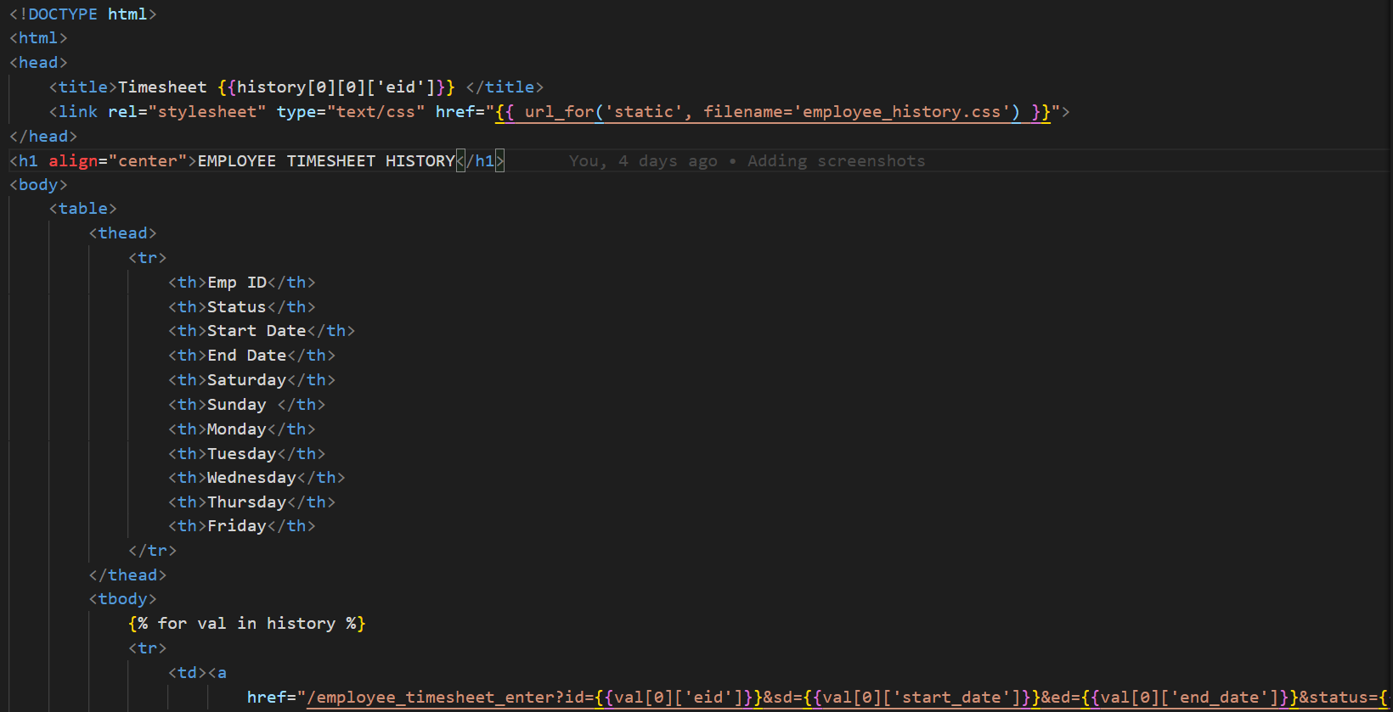

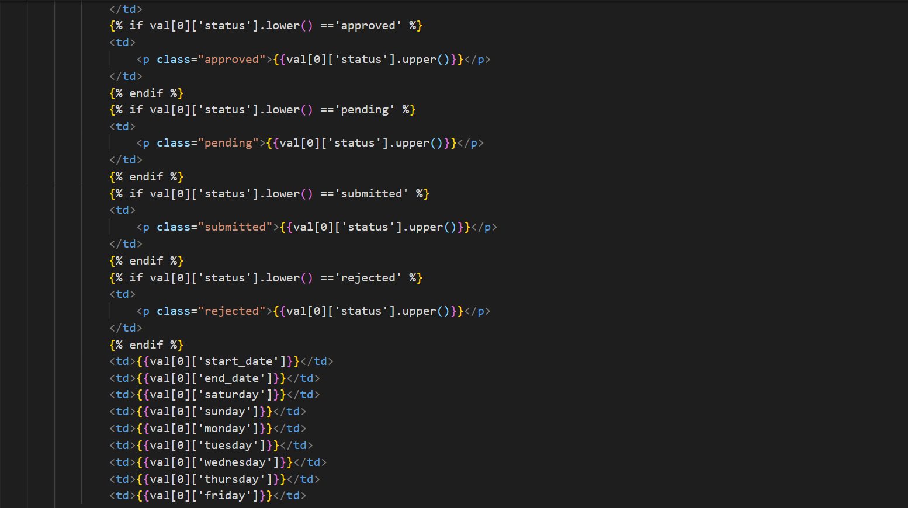

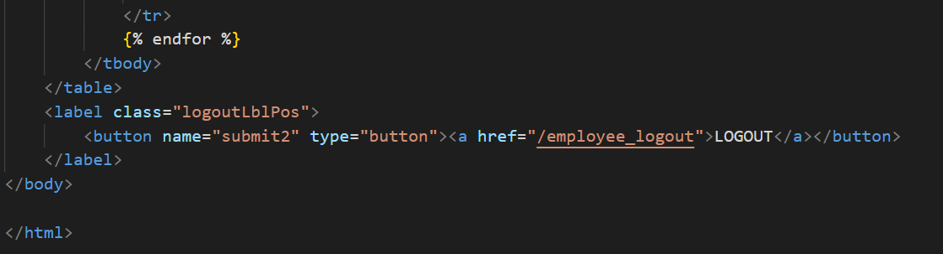

BACKEND CODE:

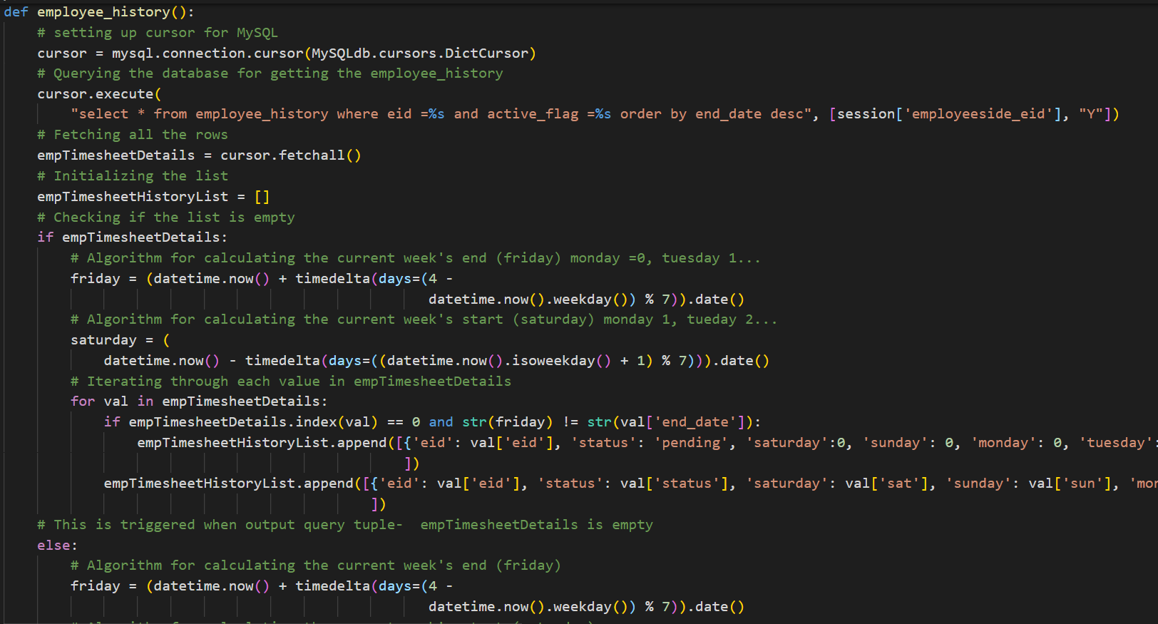

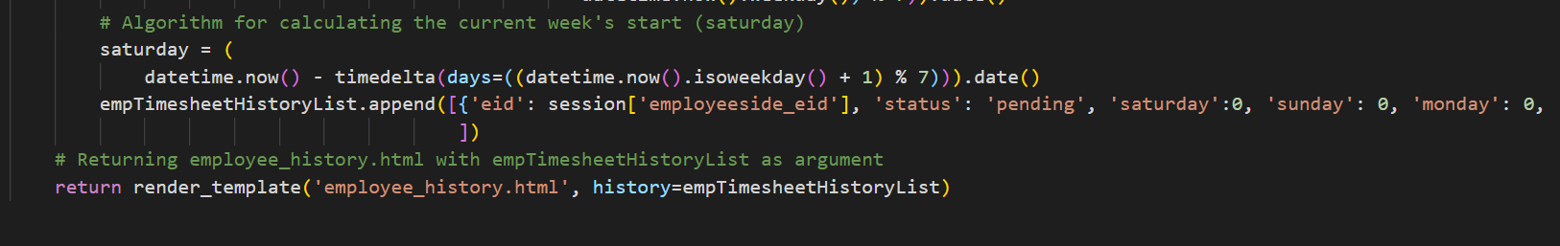

**8.4 EMPLOYEE TIMESHEET ENTER SCREEN**

On the Employee timesheet page, the user will have to enter the particular week they would like to input their timesheet. On entering the start date and end date a unique week id will be created and fed to the employee timesheet. The employee will have to enter their details with 10 referring to full day work and 0 referring to a leave. After, entering the details and clicking on submit, the details would be loaded at the admin server side. Also, the user can submit the timesheet only once, after submitting when the status is either SUBMITTED or APPROVED the submit button will be disabled, the submit button will be enabled only when the status is PENDING or REJECTED.

We made the employee timesheet landing page using html and CSS. Here in this page, the code has been done in such a way that the employee is able to easily enter the details without much of a hustle.

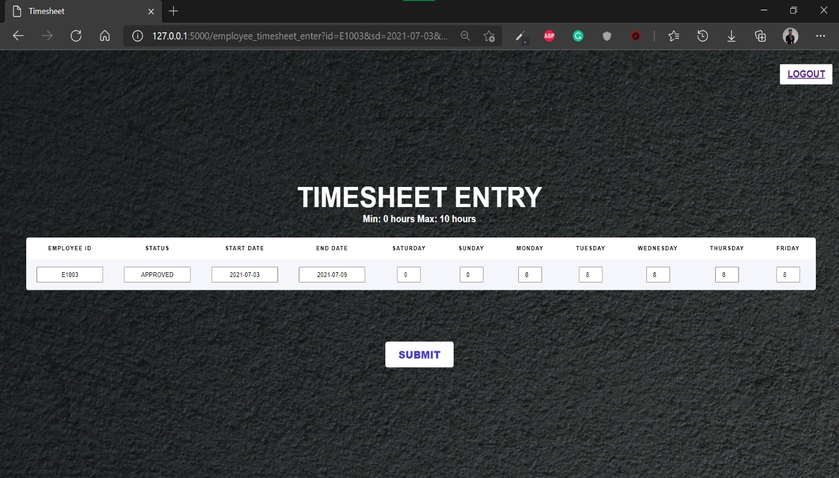

*Fig:8.4 Employee Timesheet Enter screen*

FRONT END CODE:

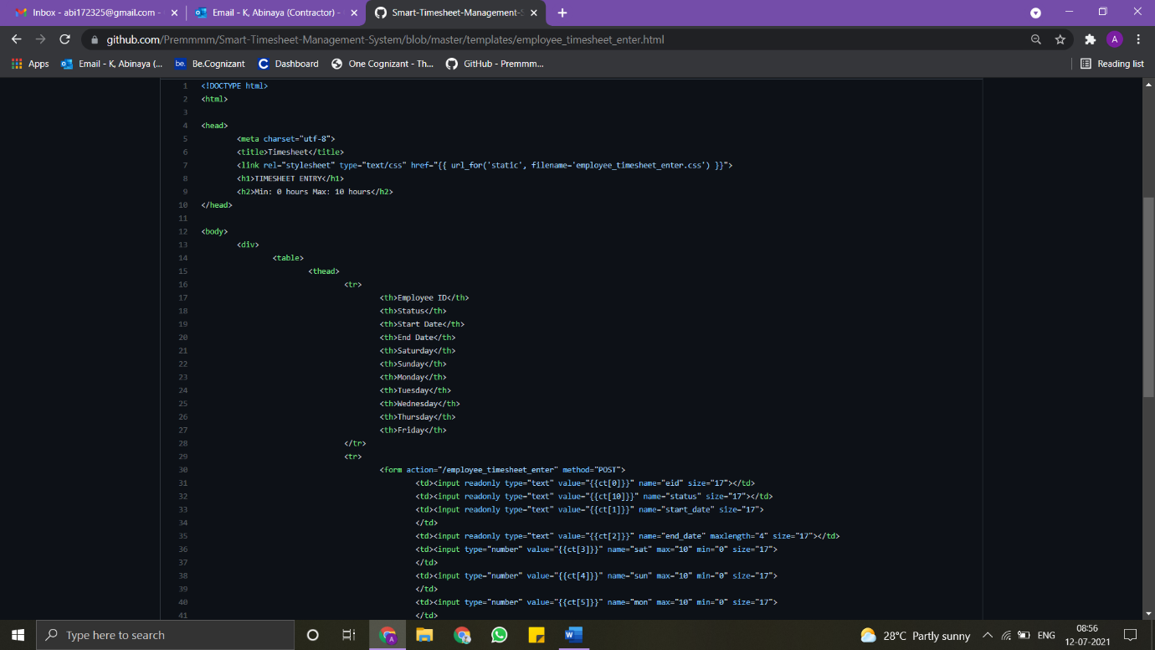

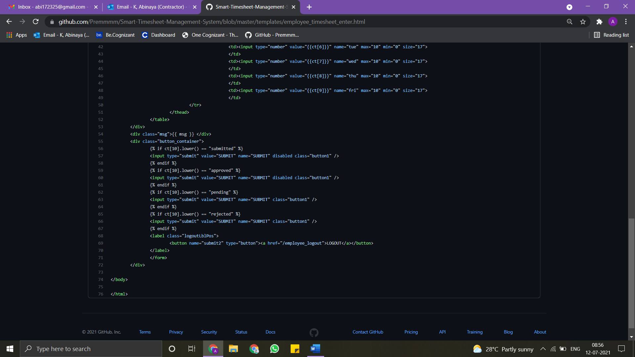

BACKEND CODE:  
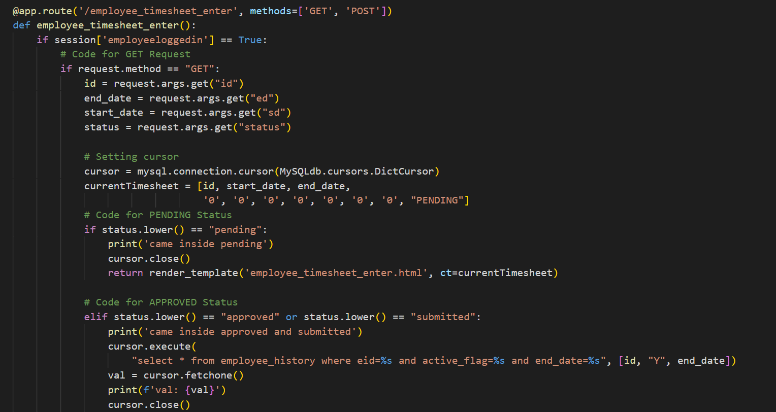

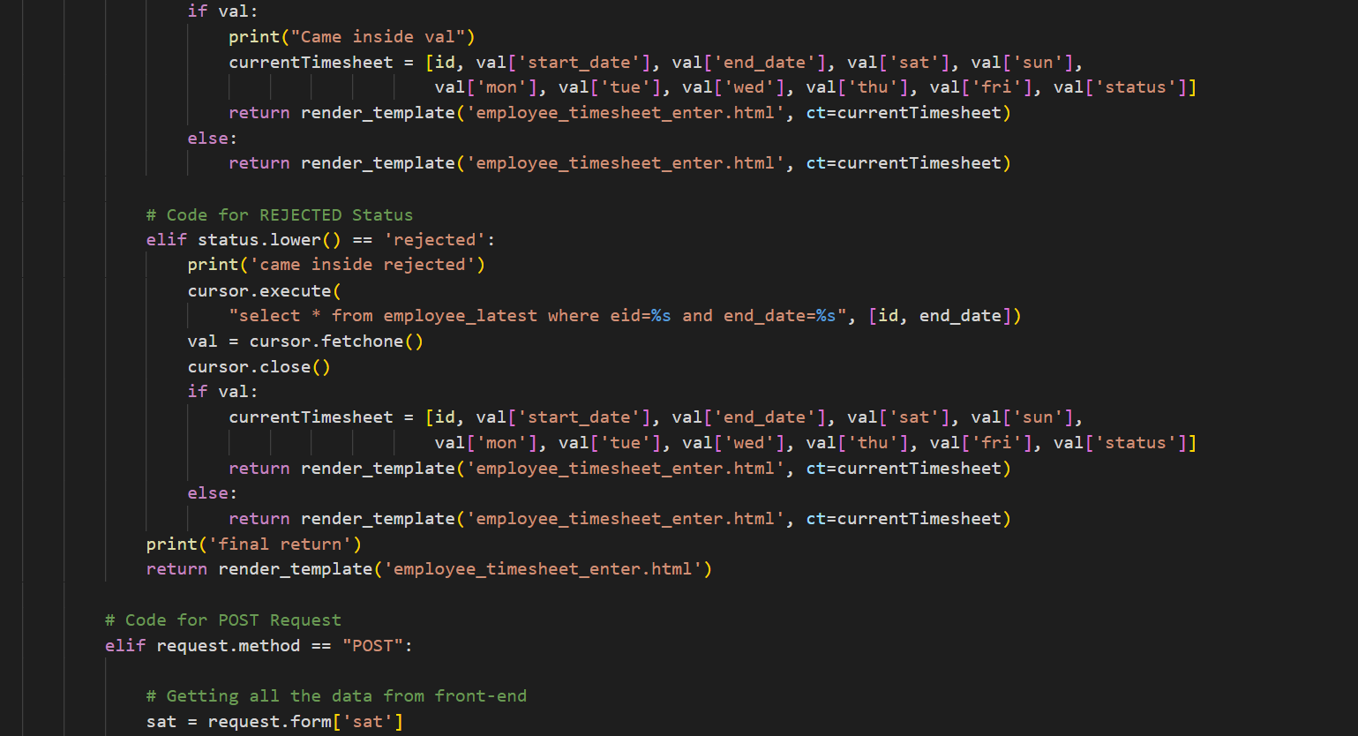

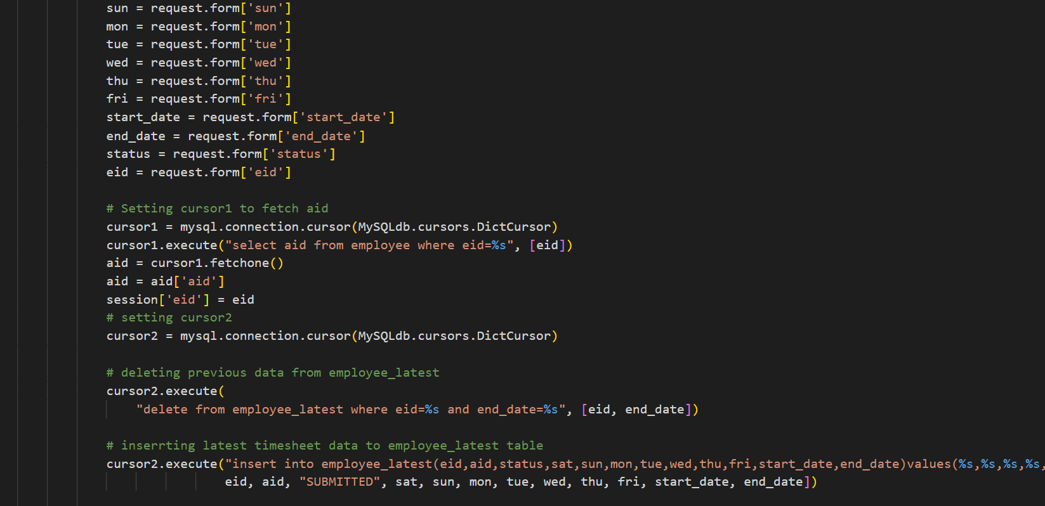

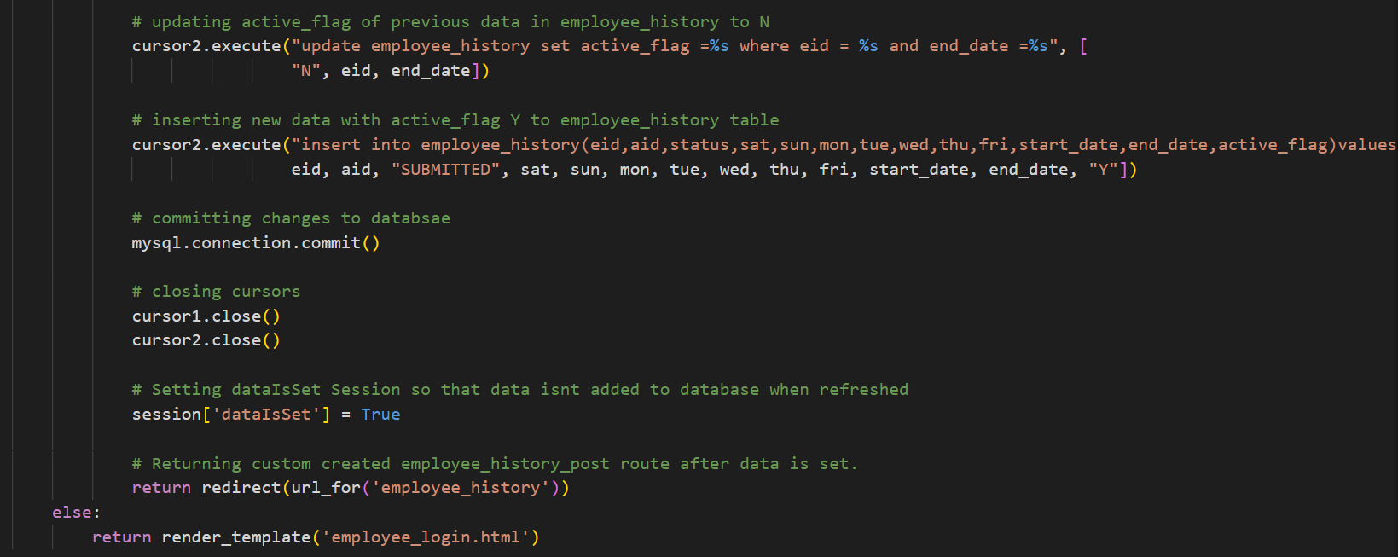

**8.5 ADMIN LOGIN SCREEN**

On clicking on the admin login from MainScreen, the admin is taken to the admin login page whereby the admin ought to enter their credentials in order to approve or reject the timesheet which has been submitted by the employees. The admin must fill the admin id, admin name and password in order to login the website.

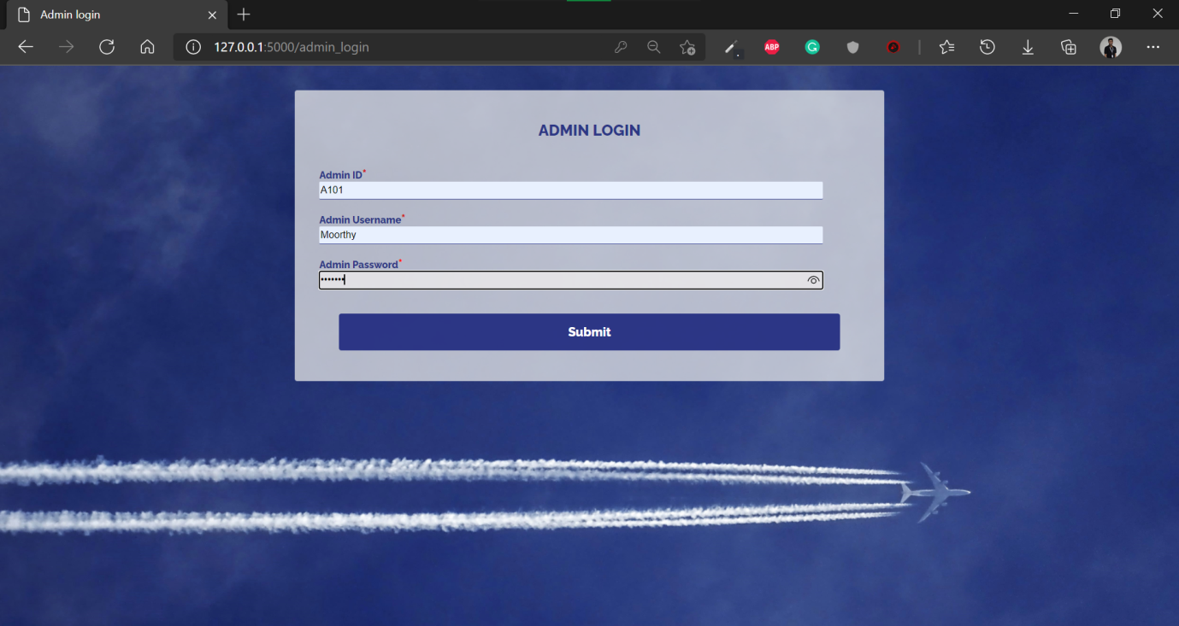

*Fig: 8.5 Admin Login Screen*

FRONT END CODE:

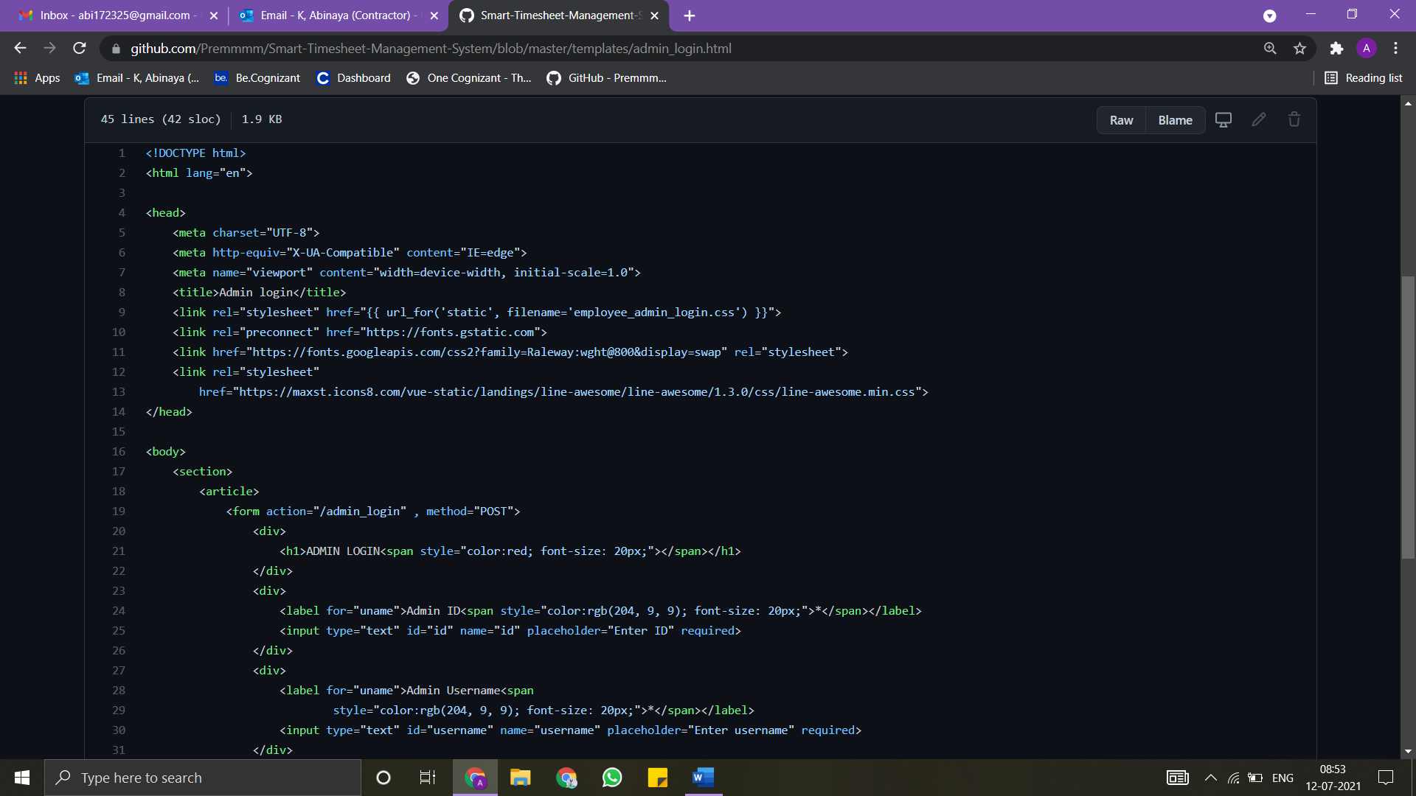

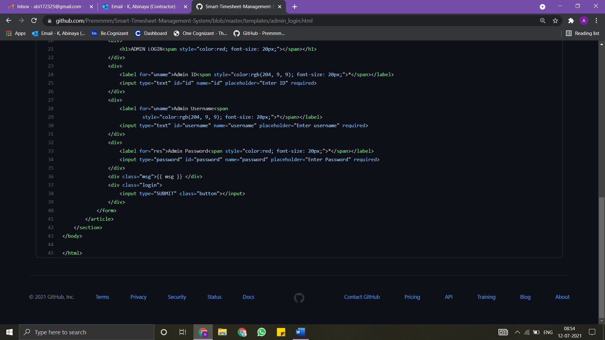

BACKEND CODE:

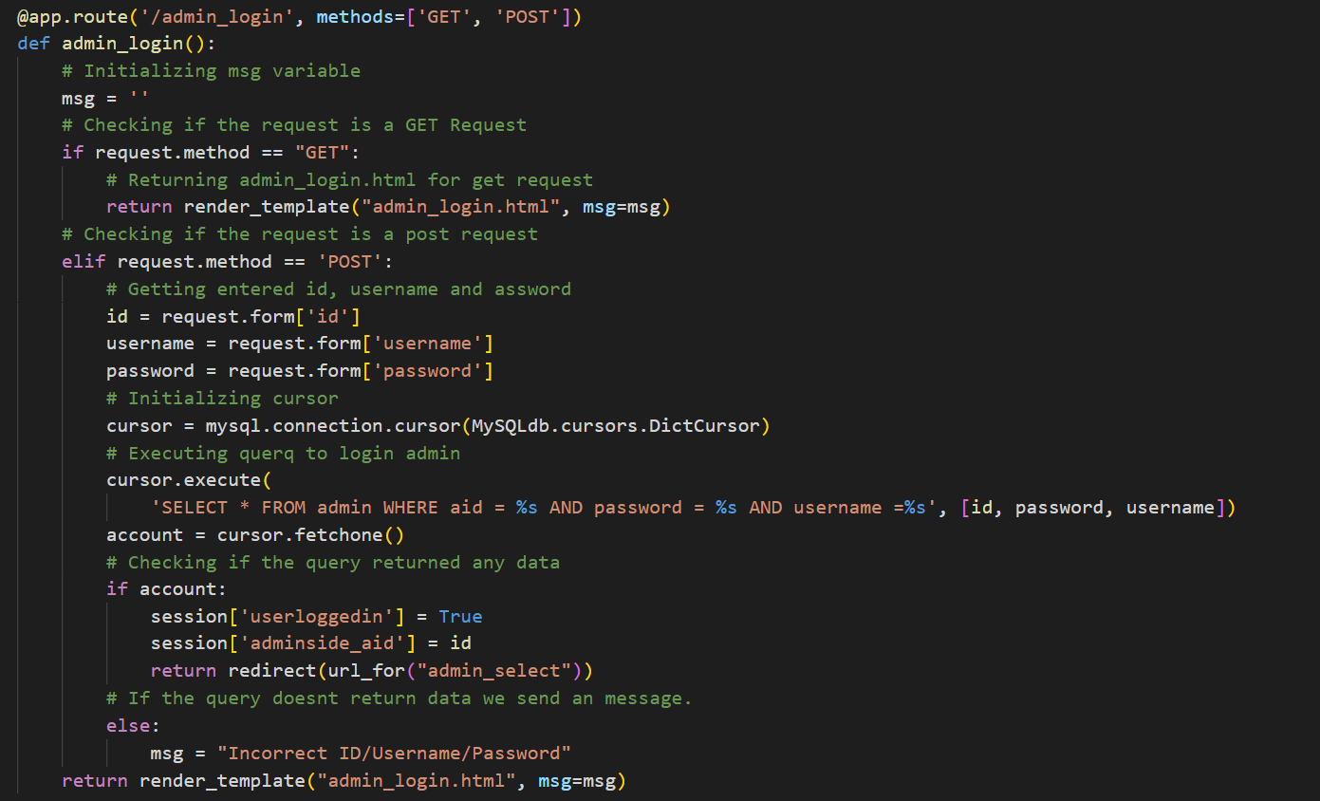

**8.6 ADMIN SELECT SCREEN**

After logging in, ithe admin will be redirected to the Admin_Select screen, where he/she will be presented with three options Pending, Approved and All, where in pending he/she can access all pending submissions, in approved all the approved submissions will be present, in all page, all the submissions and updates will be present.

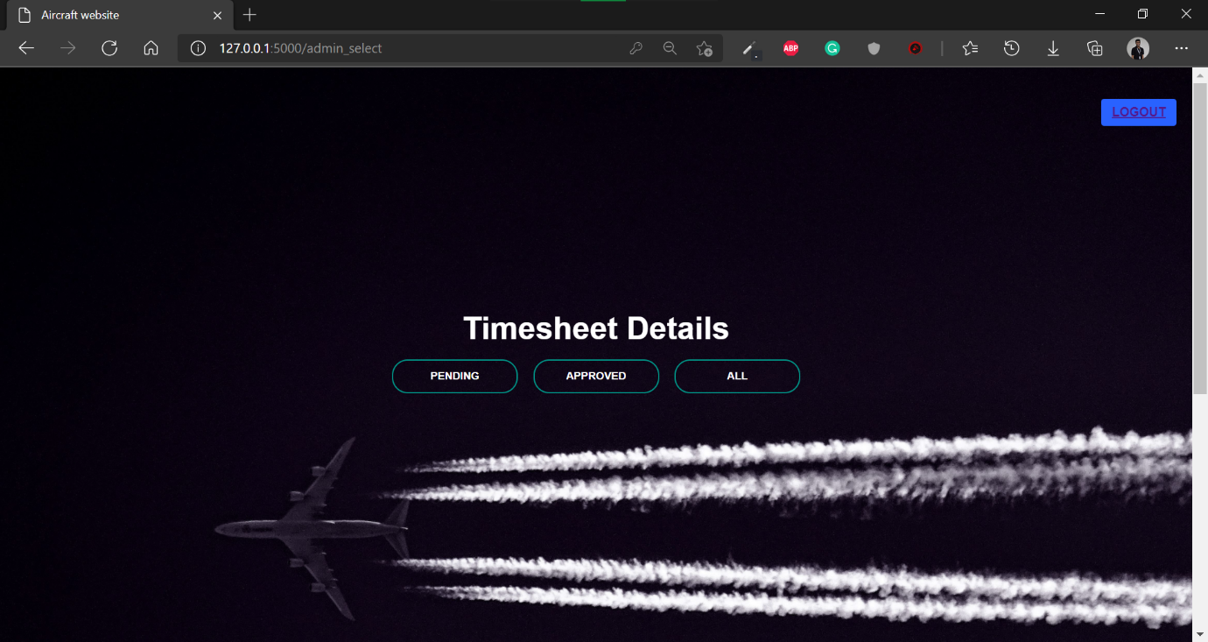

*Fig: 8.6 Admin Select Screen*

FRONTEND CODE:

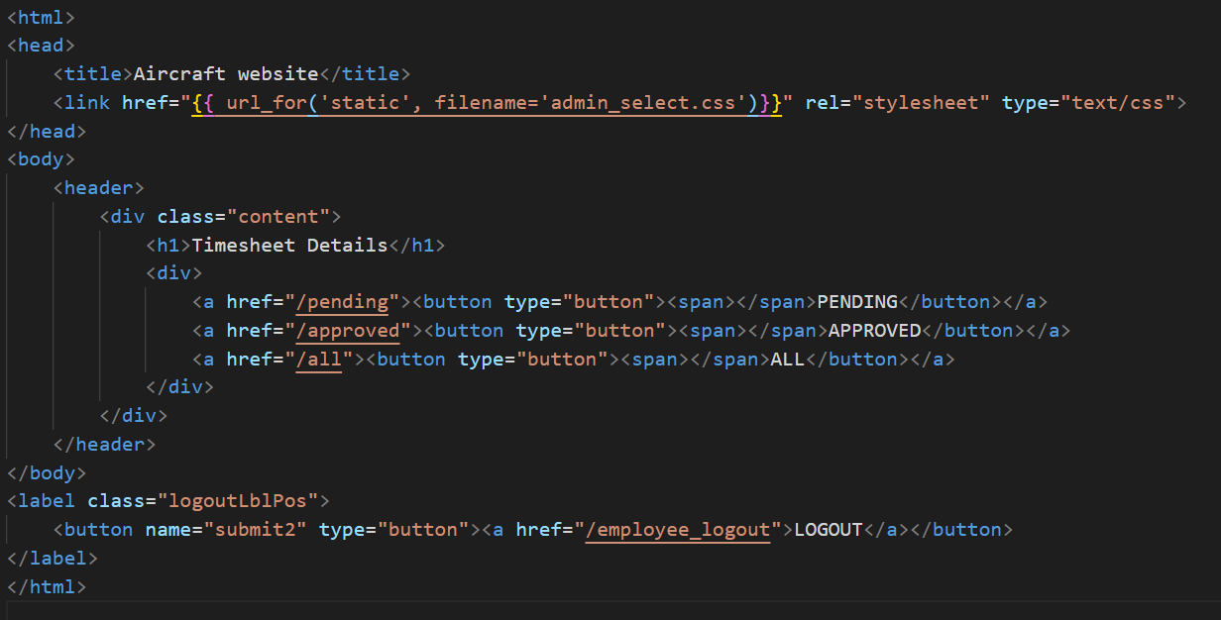

BACKEND CODE:

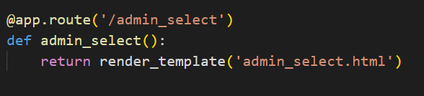

**8.7 ADMIN PENDING SCREEN**

On the Admin pending page, the details entered by the employee in the employee timesheet landing would be reflected in this page. The user would have to enter the particular employee’s id to view their timesheet details. This is done to avoid many records to be displayed and also to help the client to look for the particular record without the need to search through them.

The admin can view the pending employee timesheet to check the details and then give approve if the details entered are correct or reject if the entered details are wrong.

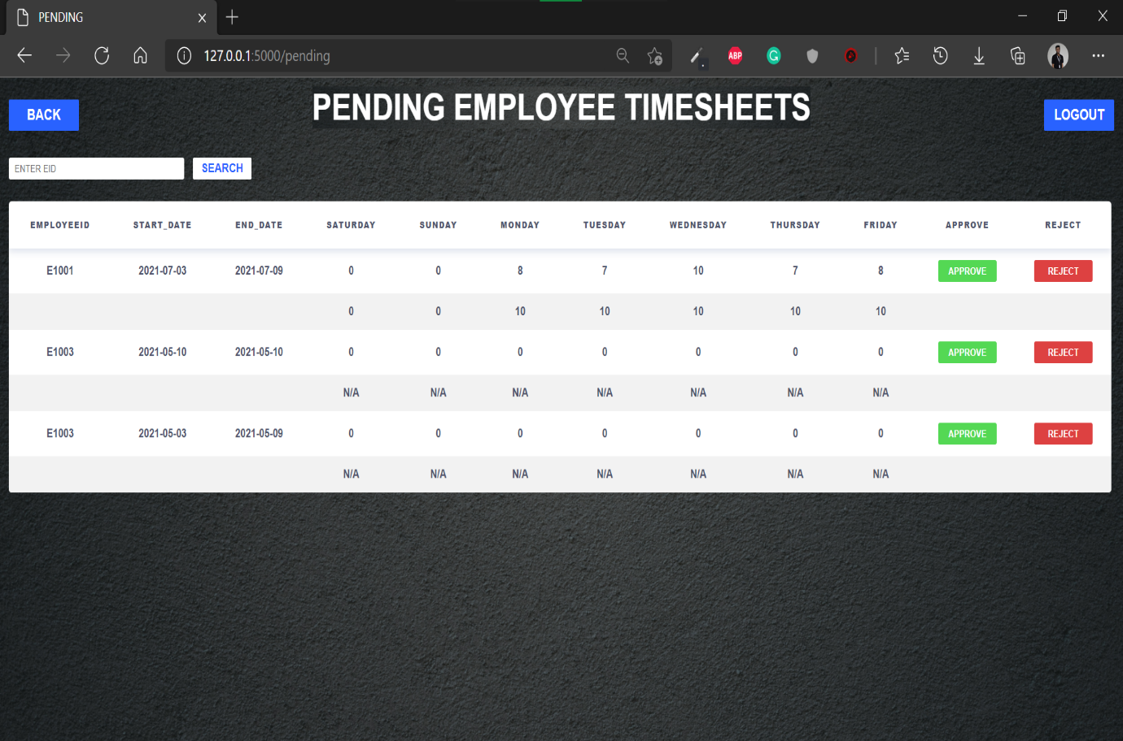

*Fig: 8.7 Admin pending screen*

FRONTEND CODE:

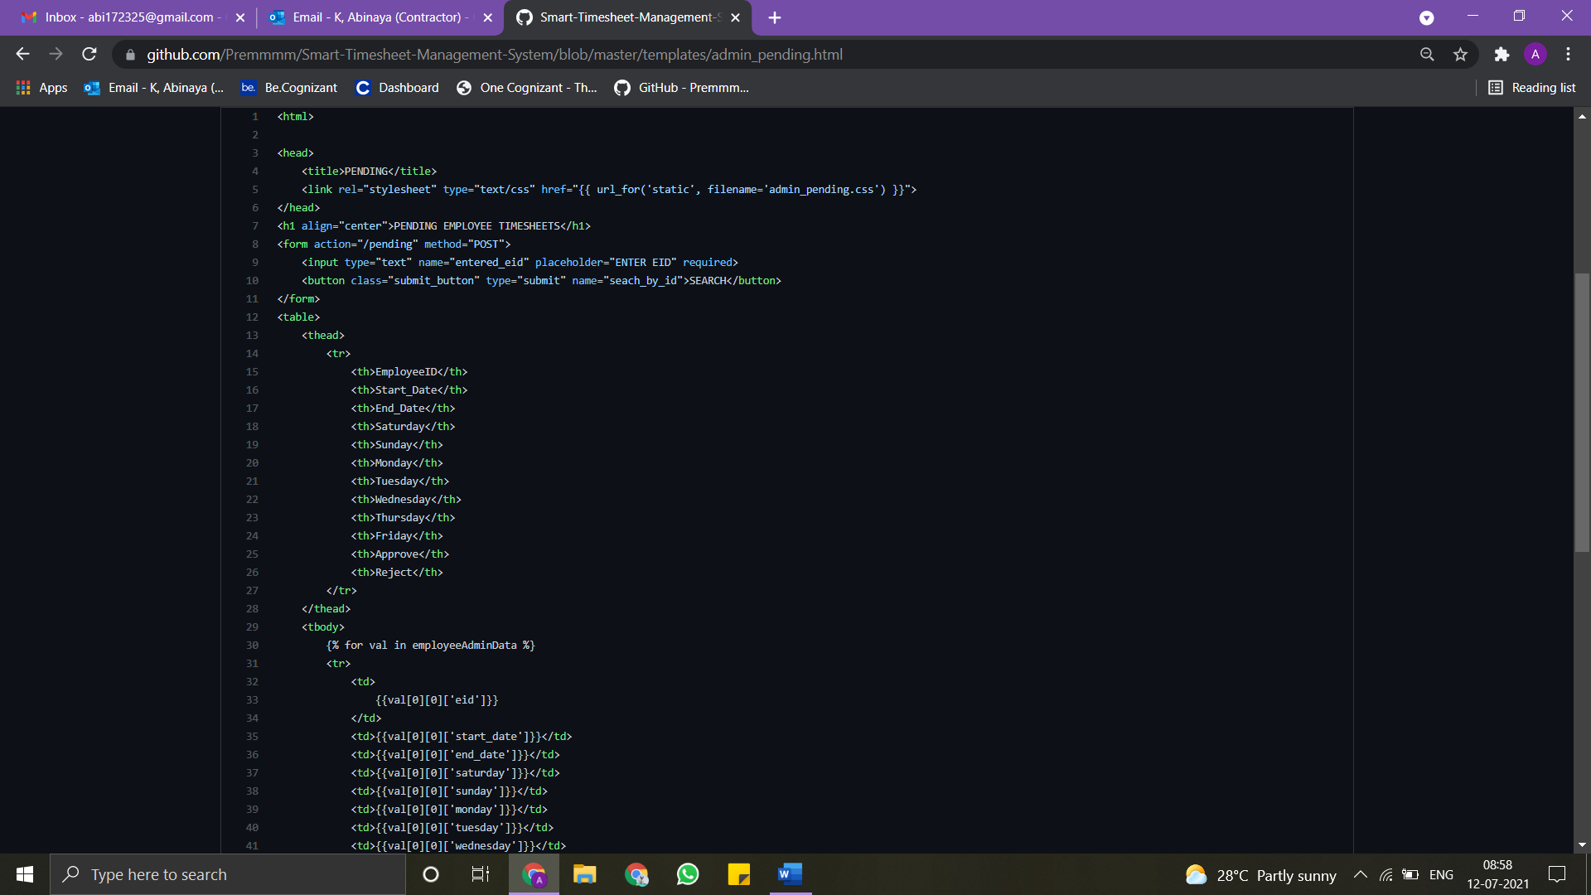

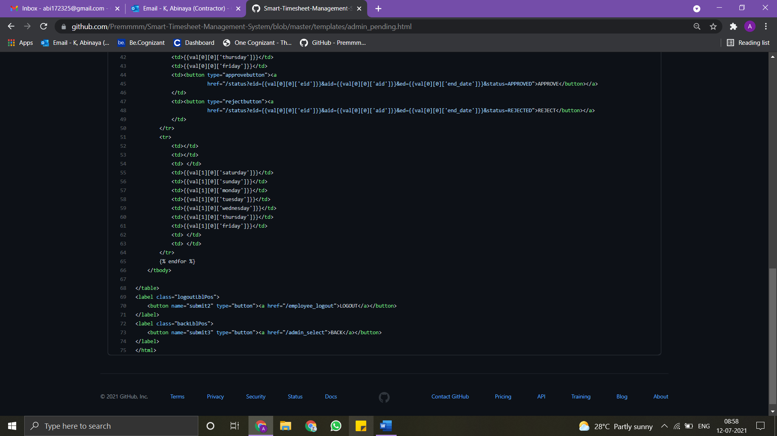

BACKEND CODE:

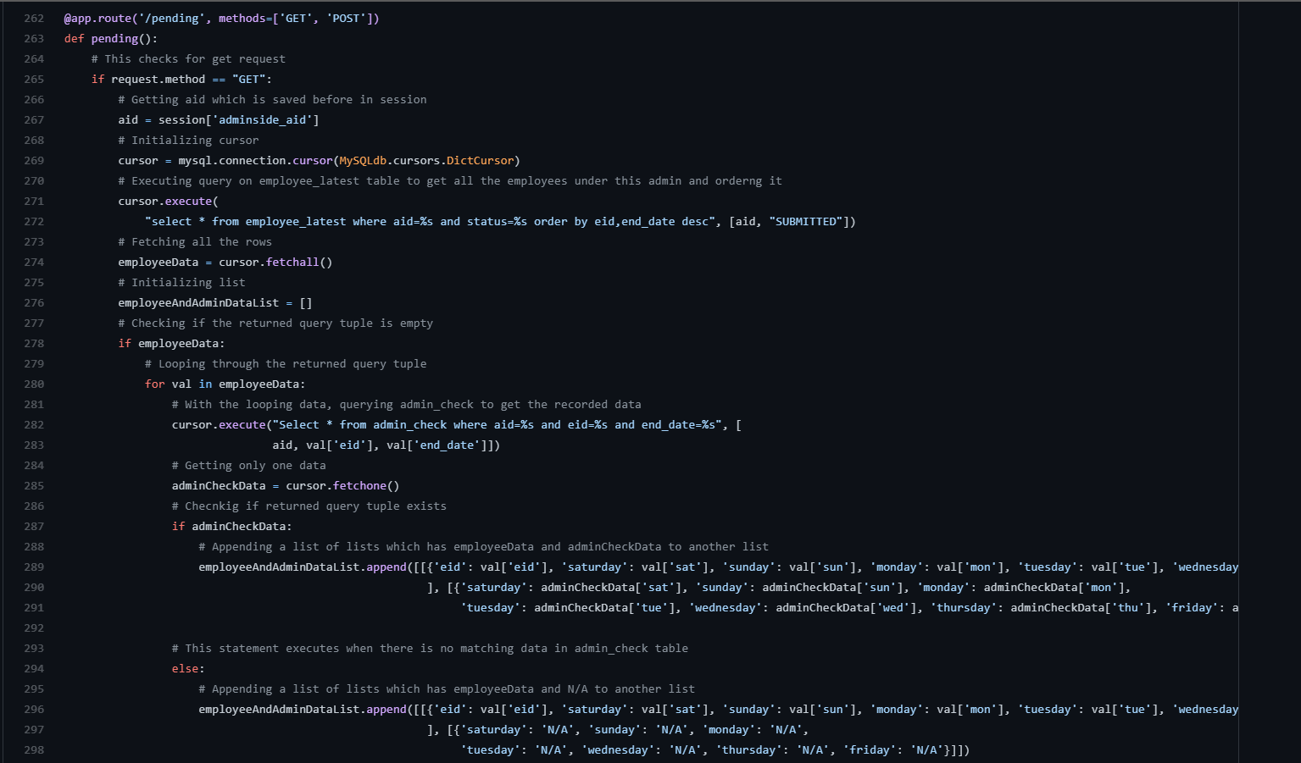

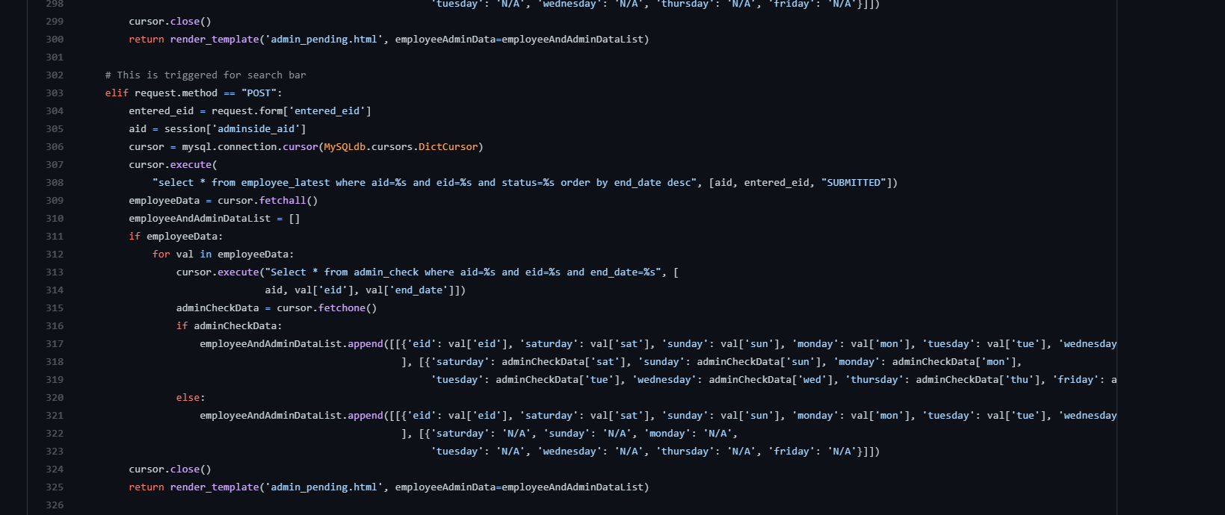

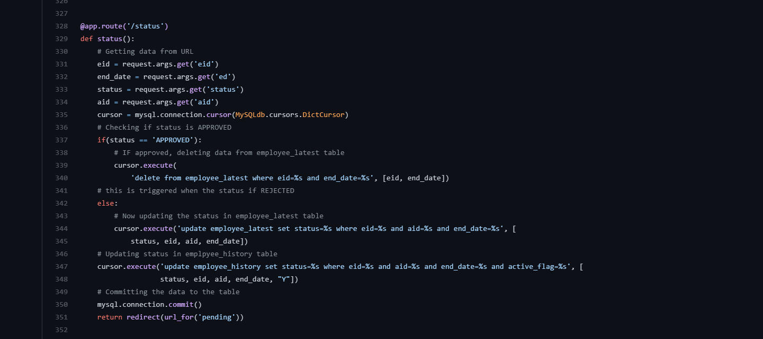

**8.8 Admin Approved Screen**

In the approved employee timesheet, it contains all the details of the employee whose timesheet is been approved by the admin. Here the data is being retrieved from the employee_history table, it is queried for the condition where active_flag is Y and the row has matching aid.

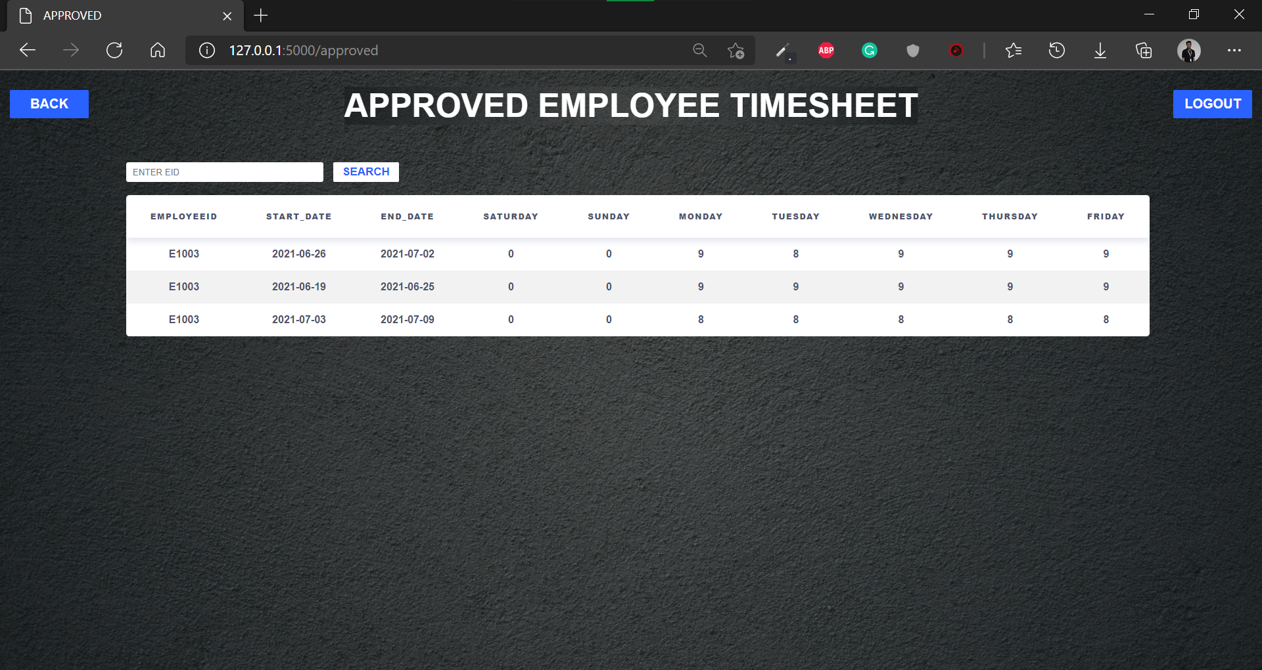

*Fig:8.8 Admin Approved Screen*

FRONTEND CODE:

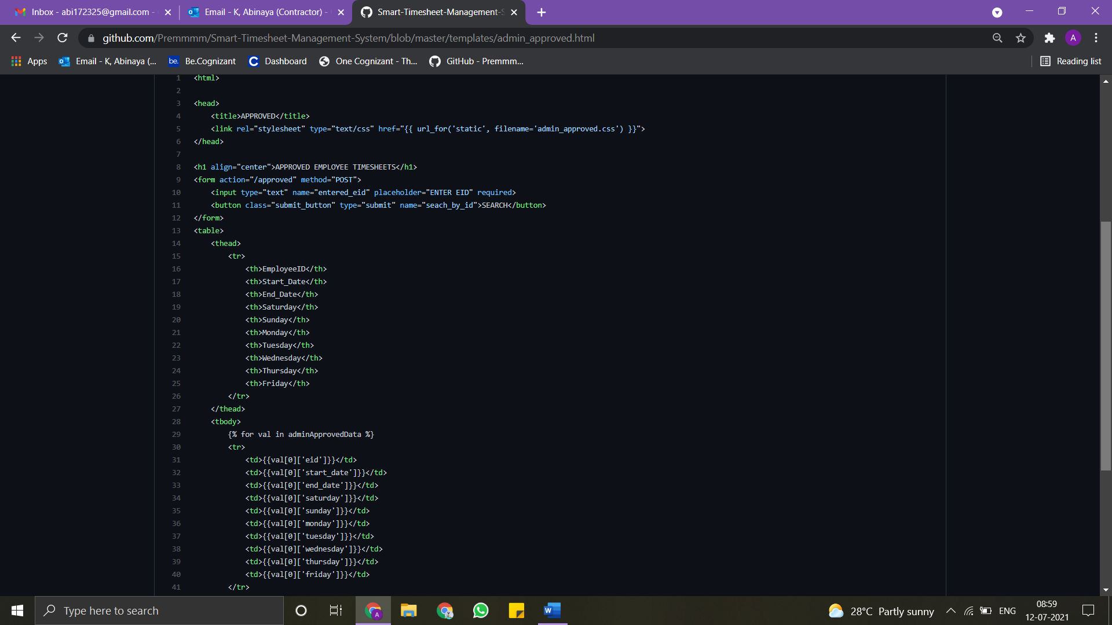

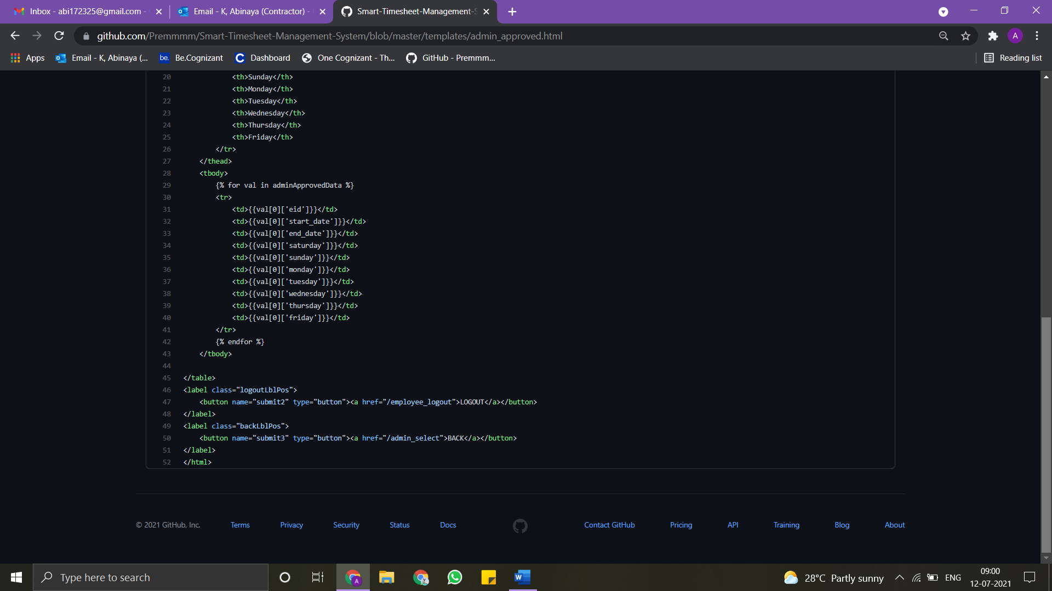

BACKEND CODE:

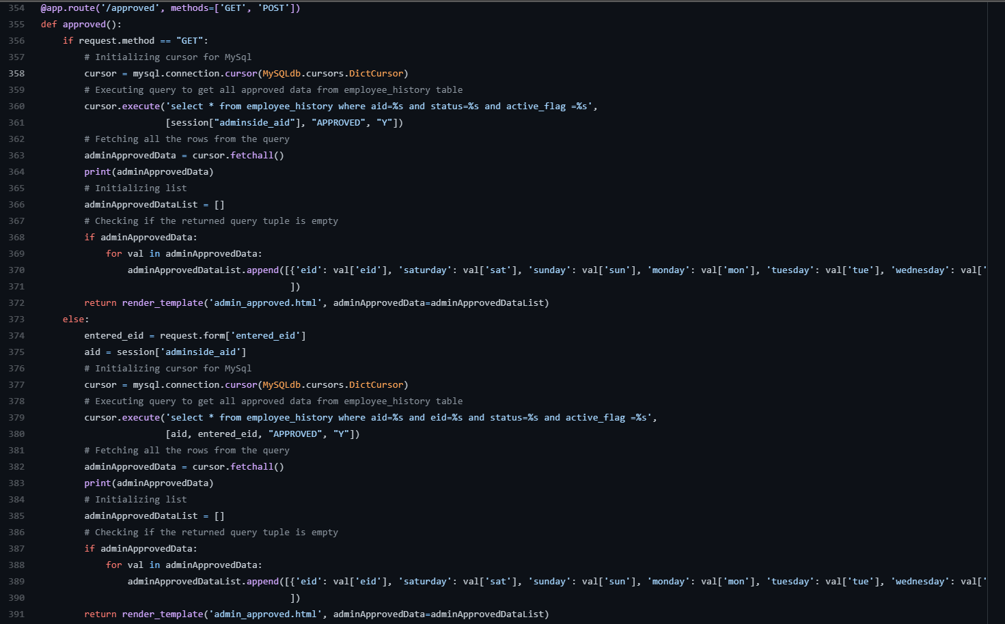

**8.9 ADMIN All SCREEN**

In the all-employee timesheet, it contains all the details of the employee whose timesheet is been approved and rejected by the admin with an active_flag column where **Y** is for approved and **N** is for rejected.

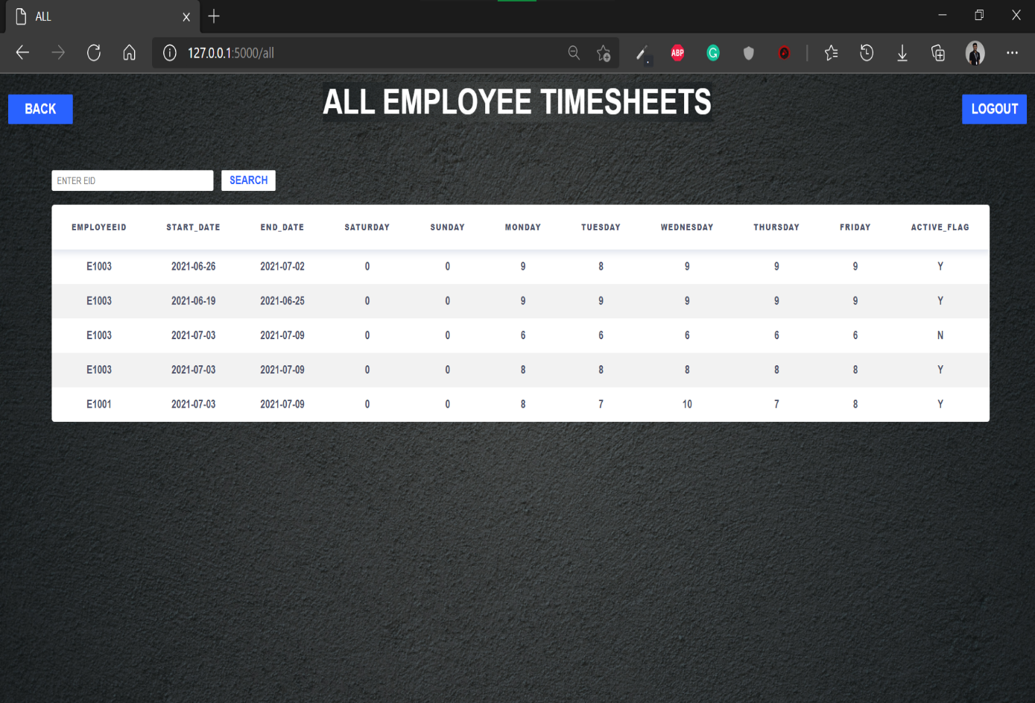

*Fig: 8.9 Admin All Screen*

FRONT END CODE:

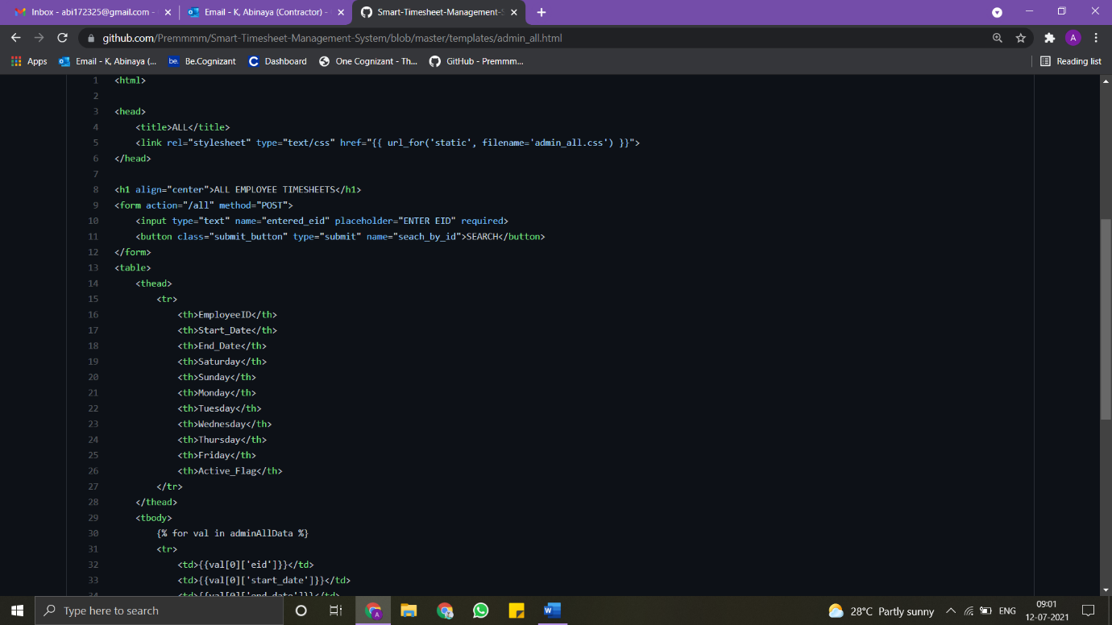

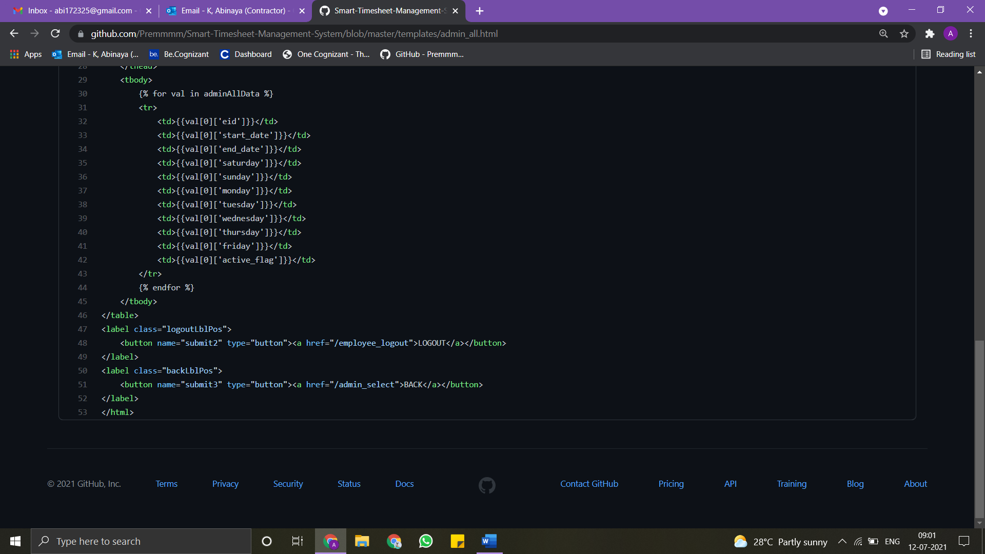

BACKEND CODE:

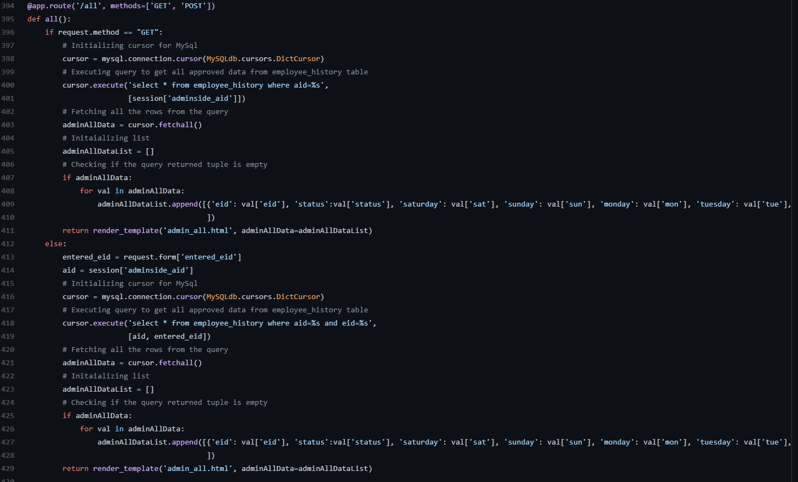

**8.10 PROJECT DATABASE PYTHON**

In Timesheet database, five tables were created to store the credentials and details of each employee and admin. The description of five tables are as follows:

Admin:

This table is used to store the login credentials of each admin. The timesheet of each employee were verified by these admins.

Employee:

This table is used to store the login credentials for each employee. Based on these credentials, employees were able to login to their timesheet website.

Employee_history:

This table is used to store the previous timesheet records of the employees. This table consists of active_flag column which takes the value “Y or N”. If the value is N, then it shows that the admin haven’t approved the timesheet entry of an employee then the status column in this table is in SUBMITTED state. After approving the entry by an admin, the flag is changed from N to Y and status is changed from SUBMITTED to APPROVED.

Employee_latest:

This table consists of the current entry of the employees. This table is same as employee_history except the thing that this table doesn’t have active_flag column.

Admin_check:

This table is managed by admin. Using this table, admins will verify the entry of an employee. Admins will track the on premise working hours of each and every employee and stored it in this table. When the employee enters their working hours in the timesheet website, the corresponding admin will cross check the working hours of the employee with their particular on premise working hours. If the both hours are same, then the admin will approve the entry otherwise he/she will reject the entry.

BACK-END CODE:

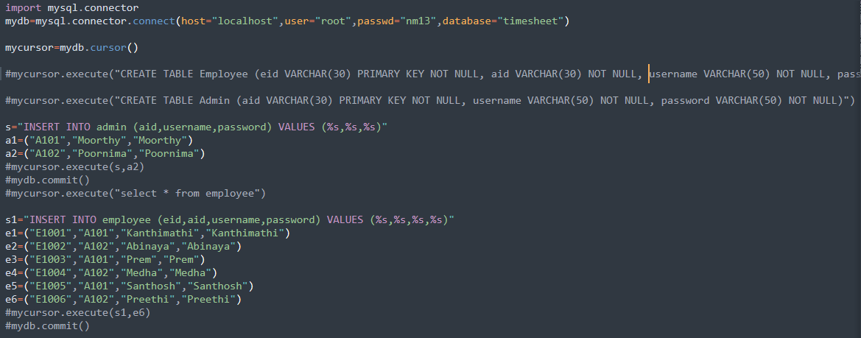

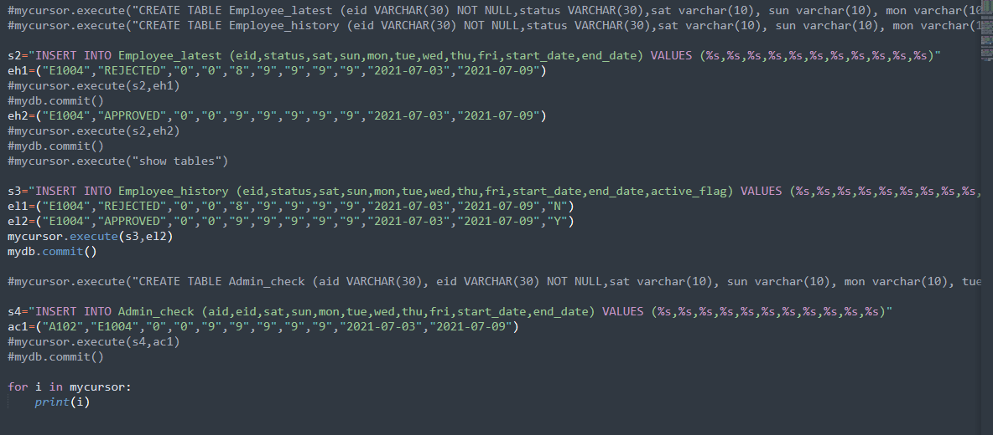

**9. CONCLUSION**

Our smart timesheet has been built with HTML and CSS for front end and flask-python as backend and MySQL as database. The website is completely optimized, safe and secured. The website is made with performance and User Interface and User Experience kept in mind. The website holds functionalities like Login Authentication, Accept and Reject timesheet submissions, Different views for Pending, Approved timesheets. Slowly changing dimension table where all the update history of the employees are stored and displayed separately with flags in a separate screen, employee’s previous submissions history and automatic date calculation have been added to the project. This is an efficient and more usable method to collect timesheet entries.